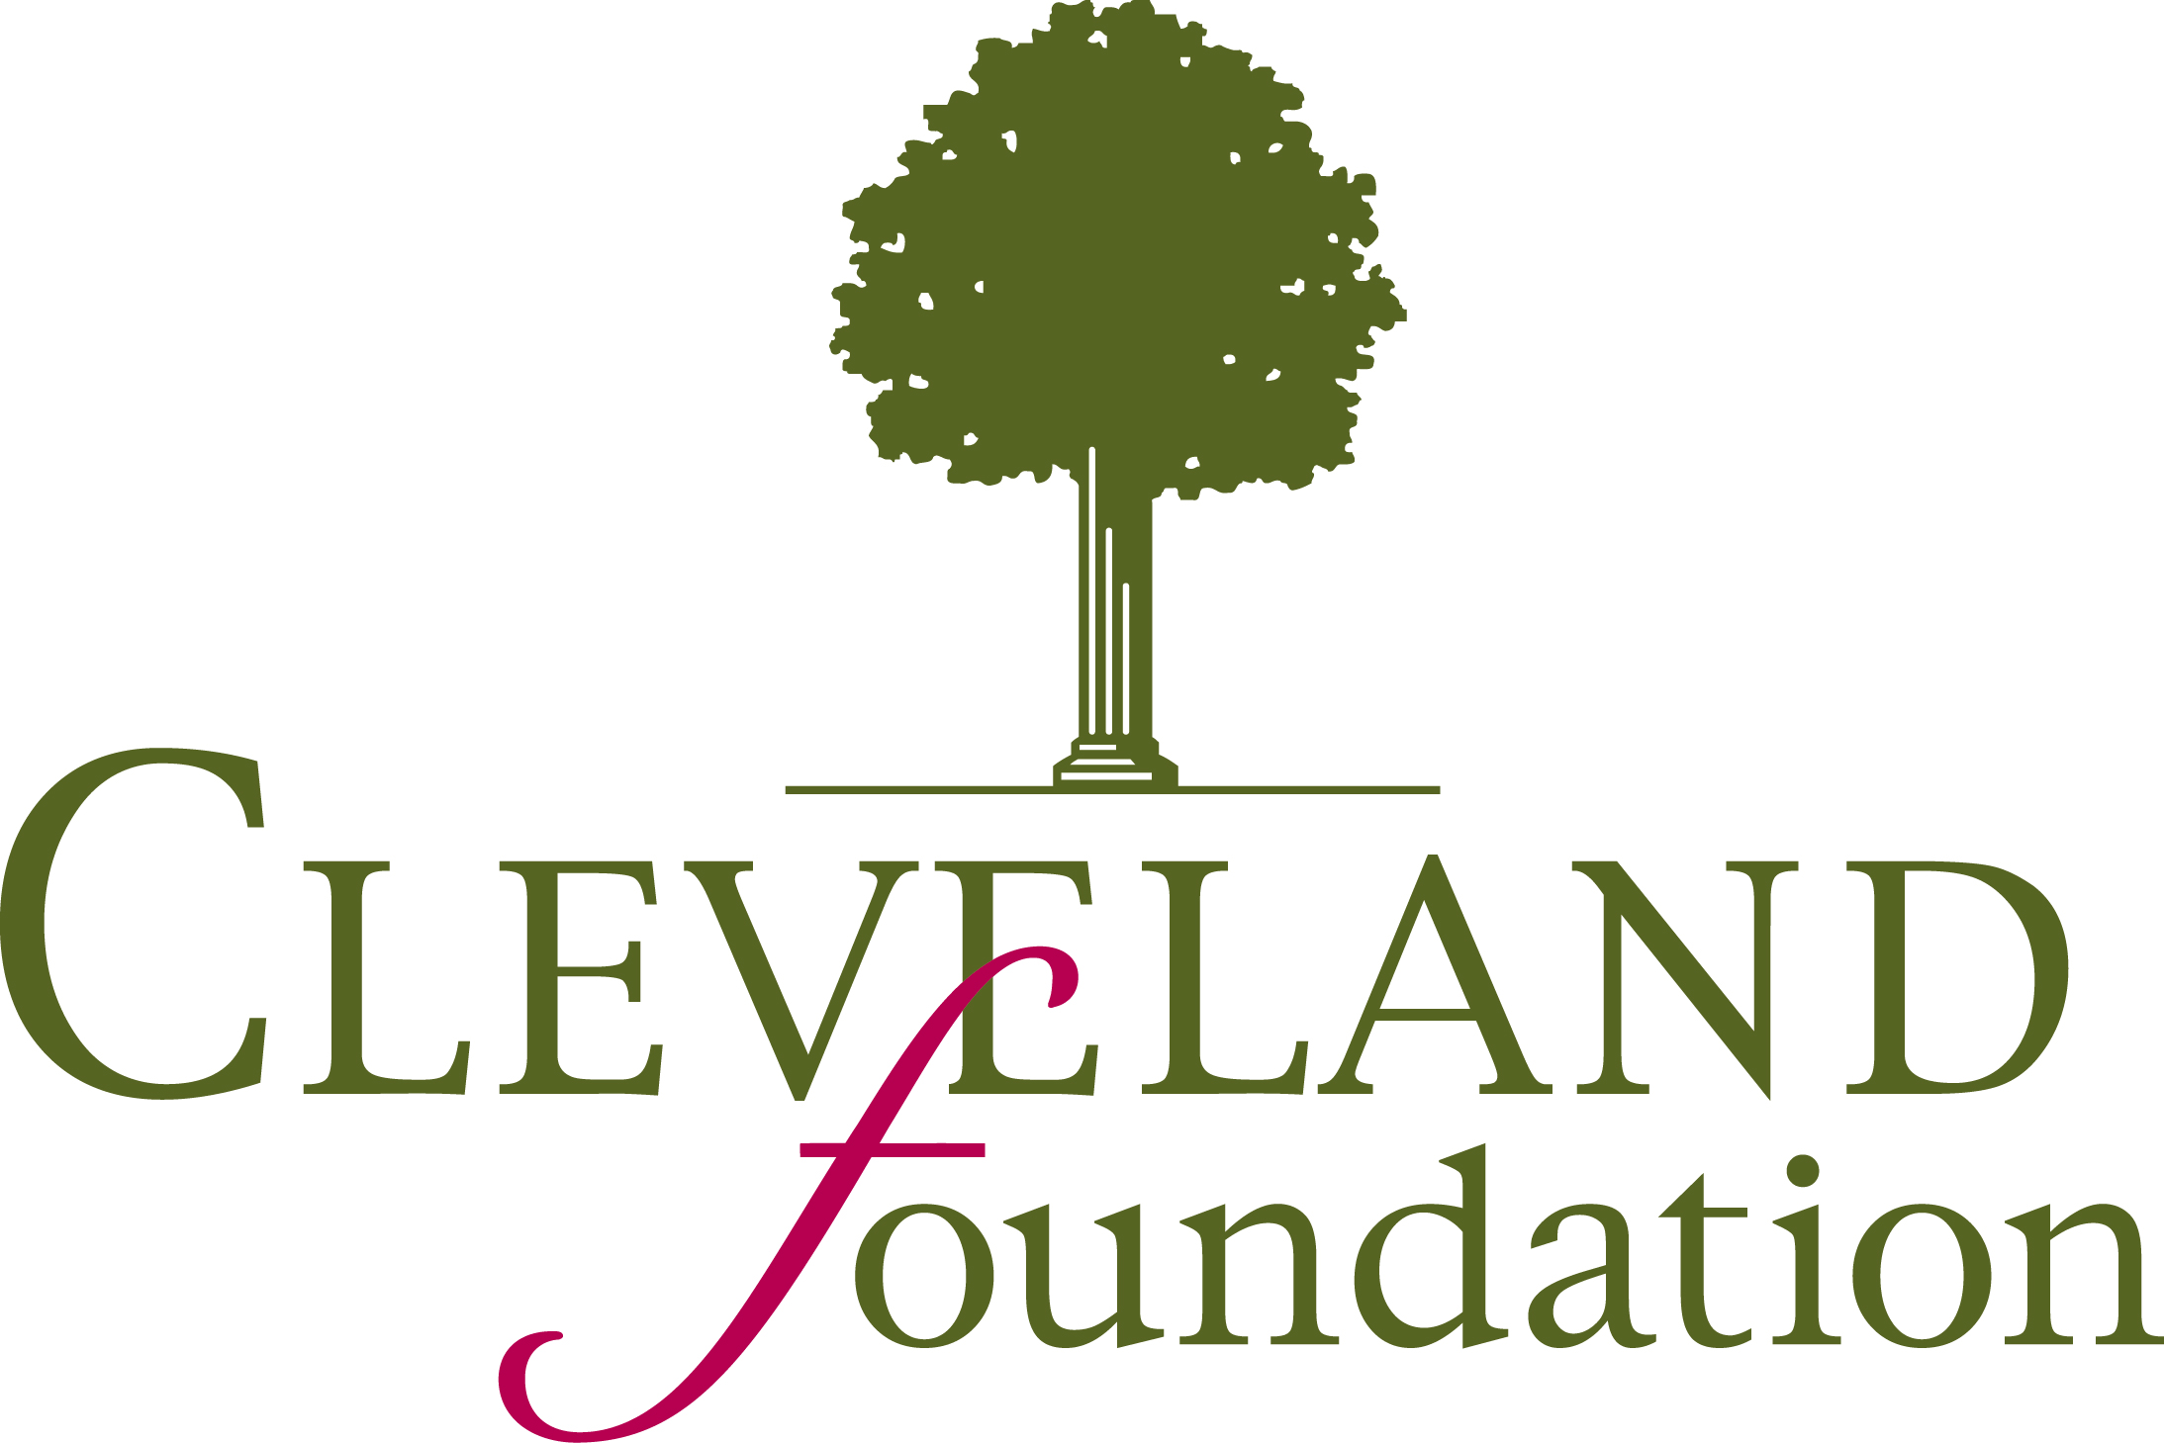


$25,000 Anisfield-Wolf Memorial Award Nomination Form

Please type (or print legibly) and submit this form and a nomination statement by Noon on June 30, 2021.

Organization:
Address:
City: State: Zip:
Phone: FAX:
Executive Director: E-mail:

Nominated by: E-mail:
Relation (if any) to Organization Nominated: Phone:
Signature* of Nominator: Date:

Organization Information
Year established:
Organization’s Annual Operating Budget:
Number of staff: Number of volunteers: Number served annually:
Name of Featured Program (optional):

Primary Target Population (choose one):
Babies Children Youth Young Adults Adults Seniors
Families (multiple age groups)

Primary Issue Addressed (choose one):
Health/Mental Health Domestic Violence: Child/Elder/Spousal
Education/Literacy Justice: Criminal/Juvenile
Employment/Workforce Other:
Hunger/Homelessness/Poverty/Self-Sufficiency

I verify that statements made in this nomination are accurate to the best of my knowledge.
Signature* of Volunteer Leader/Executive Director:

Attach a typed nomination statement of one or two 8 ½ x 11 pages with font no smaller than 11 point.

Email your completed form and your nomination statement to:
info@CommunitySolutions.com
Include the Subject Line: AW Nomination

NOMINATIONS MUST BE RECEIVED NO LATER THAN NOON, JUNE 30, 2021.
Questions? info@CommunitySolutions.com
Past winners: https://www.communitysolutions.com/previous-anisfield-wolf-memorial-award-winners/

*Electronic signature is acceptable.

